Q1. Write a Java program to convert a given integer (in seconds) to hours, minutes and seconds.

**Source Code**

import java.util.Scanner;

class sec {

public static void main(String[] args) {

Scanner sc = new Scanner(System.in);

System.out.println("ENTER DAYS");

int sec=sc.nextInt();

int hour=sec/3600;

int min = (sec-hour*3600)/60;

sec = sec%60;

System.out.println("H:M:S : " + hour +":" + min +":"+sec);

}

}

**Output**

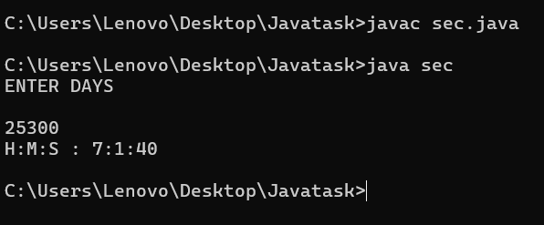

Q2. Write a java program to convert a given integer (in days) to years, months and  days,assumes that all months have 30 days and all years have 365 days.

**Source Code**

import java.util.Scanner;

class days {

public static void main(String[] args) {

Scanner sc = new Scanner(System.in);

System.out.println("ENTER DAYS");

int days=sc.nextInt();

int yr = days/365;

days = days%365;

int month = days/30;

days = days%30;

System.out.println(yr + "Years");

System.out.println(month + "month");

System.out.println(days + "Days");

}

}

**Output**

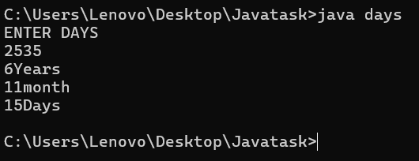

Q3. . Write a java program that read 5 numbers and sum of all odd values between them.

Source Code

import java.util.Scanner;

class Sumodd {

public static void main(String[] args) {

Scanner sc = new Scanner(System.in);

int sum = 0;

for (int i=1 ; i<=6;i++){

System.out.println("ENTER NUMBER " + i);

int num = sc.nextInt();

if (num%2!=0){

sum = sum+num;

num = 0;

}

}

System.out.println("THE sum is " + sum);

}

}

**Output**

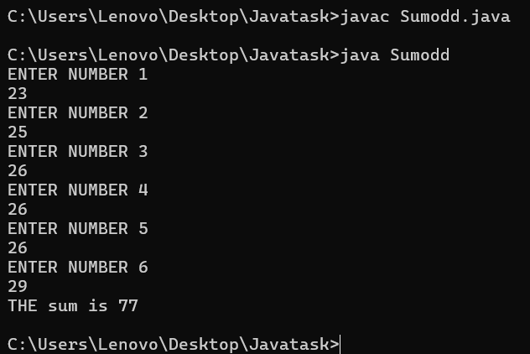

Q4. Write a Java program that reads two integers and checks whether they are  multiplied or not.

**Source Code**

import java.util.*;

class multiplied {

public static void main(String[] args) {

Scanner sc = new Scanner(System.in);

System.out.println("ENTER FIRST VALUE");

int a = sc.nextInt();

System.out.println("ENTER SECOND VALUE");

int b = sc.nextInt();

if (a%b==0){

System.out.println("multiplied");

}

else{

System.out.println("Not multiplied");

}

}

}

**Output**

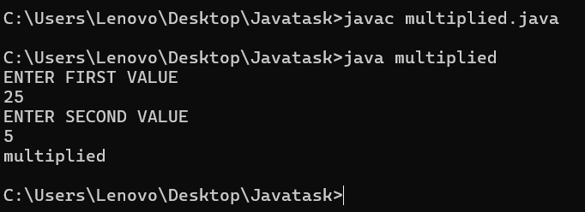

**Q5. Write a Java program that reads an integer between 1 and 12 and print the month of  the year in English.**

**Source Code**

import java.util.Scanner;

class month {

public static void main(String[] args) {

Scanner sc = new Scanner(System.in);

System.out.print("Input a number between 1 to 12 to get the month name : ");

int a = sc.nextInt();

if(a==1){

System.out.println("THE MONTH IS JANUARY");

}

else if(a==2){

System.out.println("THE MONTH IS FEBRUARY");

}

else if(a==3){

System.out.println("THE MONTH IS MARCH");

}

else if(a==4){

System.out.println("THE MONTH IS APRIL");

}

else if(a==5){

System.out.println("THE MONTH IS MAY");

}

else if(a==6){

System.out.println("THE MONTH IS JUNE");

}

else if(a==7){

System.out.println("THE MONTH IS JULY");

}

else if(a==8){

System.out.println("THE MONTH IS AUGUST");

}

else if(a==9){

System.out.println("THE MONTH IS SEPTEMBER");

}

else if(a==10){

System.out.println("THE MONTH IS OCTOBER");

}

else if(a==11){

System.out.println("THE MONTH IS NOVEMBER");

}

else if(a==12){

System.out.println("THE MONTH IS DECEMBER");

} else{

System.out.println("ENTER VALID MONTH NUMBER");

}

}

}

**Output**

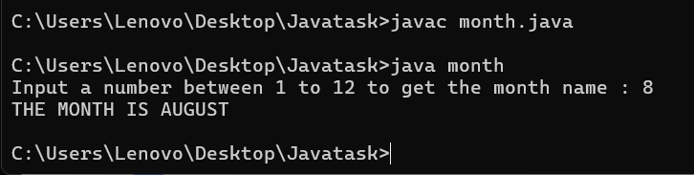

**Q6. Write a java program that read 5 numbers and counts the number of positive  numbersand negative numbers.**

**Source Code**

import java.util.Scanner;

class totpos {

public static void main(String[] args) {

int odd,even;

odd = 0;

even = 0;

Scanner sc = new Scanner(System.in);

System.out.print("ENTER FIRST NUMBER ");

int a1= sc.nextInt();

System.out.print("ENTER SECOND NUMBER ");

int a2 = sc.nextInt();

System.out.print("ENTER THIRD NUMBER ");

int a3 = sc.nextInt();

System.out.print("ENTER FOURTH NUMBER ");

int a4 = sc.nextInt();

System.out.print("ENTER FIFTH NUMBER ");

int a5 = sc.nextInt();

if(a1>0){

odd++;

}else{

even++;

}

if(a2>0){

odd++;

}else{

even++;

}

if(a3>0){

odd++;

}else{

even++;

}

if(a4>0){

odd++;

}else{

even++;

}

if(a5>0){

odd++;

}else{

even++;

}

System.out.println("NUMBER OF POSITIVE VALUE" + odd);

System.out.println("NUMBER OF NEGATIVE VALUE" + even);

}

}

**Output**

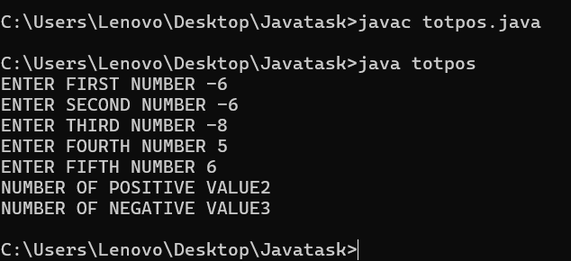

Q7. Write a java program that read 5 numbers and counts the number of positive  numbersand print the average of all positive values.

Source Code

import java.util.Scanner;

class avgpos {

public static void main(String[] args) {

int pos,neg,sum;

pos = 0;

neg = 0;

sum = 0;

Scanner sc = new Scanner(System.in);

System.out.print("ENTER FIRST NUMBER ");

int a1= sc.nextInt();

System.out.print("ENTER SECOND NUMBER ");

int a2 = sc.nextInt();

System.out.print("ENTER THIRD NUMBER ");

int a3 = sc.nextInt();

System.out.print("ENTER FOURTH NUMBER ");

int a4 = sc.nextInt();

System.out.print("ENTER FIFTH NUMBER ");

int a5 = sc.nextInt();

if(a1>0){

pos++;

sum = sum+a1;

}else{

neg++;

}

if(a2>0){

pos++;

sum = sum+a2;

}else{

neg++;

}

if(a3>0){

pos++;

sum = sum+a3;

}else{

neg++;

}

if(a4>0){

pos++;

sum = sum+a4;

}else{

neg++;

}

if(a5>0){

pos++;

sum = sum+a5;

}else{

neg++;

}

System.out.println("NUMBER OF POSITIVE VALUE " + pos);

int avg = sum/pos;

System.out.println("THE AVERAGE IS " + avg);

}

}

Output

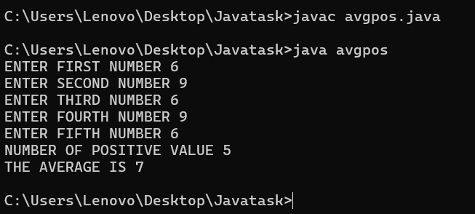

Q8. Write a java program that read 5 numbers and sum of all odd values  betweenthem.

Source Code

import java.util.Scanner;

class oddsum {

public static void main(String[] args) {

int sum;

sum = 0;

Scanner sc = new Scanner(System.in);

System.out.print("ENTER FIRST NUMBER ");

int a1= sc.nextInt();

System.out.print("ENTER SECOND NUMBER ");

int a2 = sc.nextInt();

System.out.print("ENTER THIRD NUMBER ");

int a3 = sc.nextInt();

System.out.print("ENTER FOURTH NUMBER ");

int a4 = sc.nextInt();

System.out.print("ENTER FIFTH NUMBER ");

int a5 = sc.nextInt();

if(a1%2!=0){

sum = sum+a1;

}

if(a2%2!=0){

sum = sum+a2;

}

if(a3%2!=0){

sum = sum+a3;

}

if(a4%2!=0){

sum = sum+a4;

}

if(a5%2!=0){

sum = sum+a5;

}

System.out.println("THE SUM OF ODD NUMBER IS " + sum);

}

}

Output

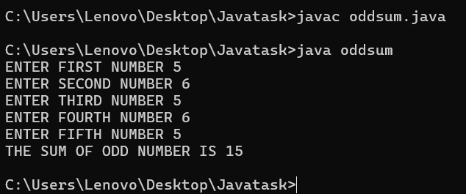

Q9. Write java program that converts Centigrade to Fahrenheit.

Source Code

import java.util.Scanner;

class tempr {

public static void main(String[] args) {

float cen,fer;

Scanner sc = new Scanner(System.in);

System.out.println("ENTER THE TEMPRATURE IN CELCIUS");

cen = sc.nextFloat();

fer=(9*cen +(32*5))/5;

System.out.println("THE TEMPRATURE IN FEHRENHEIT " + fer);

}

}

**Output**

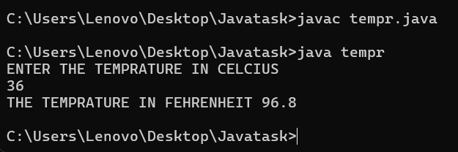

Q10. Write a java program that converts kilometers per hour to miles per hour

Source Code

import java.util.Scanner;

class speed {

public static void main(String[] args) {

float km;

Scanner sc = new Scanner(System.in);

System.out.println("ENTER SPEED IN KM/H");

km = sc.nextFloat();

double m = km*0.62137;

System.out.println("SPEED IN MILES PER HOURS IS " + m);

}

}

**Output**

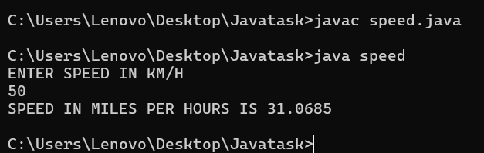

Q11. Write a java program to check two given integers, and print true if one of them is 30 or if their sum is 30 else print false.

Source Code

import java.util.Scanner;

class sum30 {

public static void main(String[] args) {

Scanner sc = new Scanner(System.in);

int a,b,c;

System.out.println("enter first number");

a = sc.nextInt();

System.out.println("enter second number");

b = sc.nextInt();

c=a+b;

if(a==30 || b==30){

System.out.println("TRUE");

}

else if(c==30){

System.out.println("TRUE");

}

else{

System.out.println("FALSE");

}

}

}

**Output**

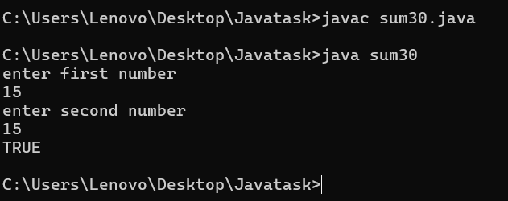

Q12. Write a java program that takes hours and minutes as input, and calculates the total number of minutes

Source Code

import java.util.Scanner;

class minutes {

public static void main(String[] args) {

Scanner sc = new Scanner(System.in);

int hr,min;

System.out.println("Enter Hours");

hr=sc.nextInt();

System.out.println("Enter Minutes");

min=sc.nextInt();

hr = hr*60;

min = min+hr;

System.out.println("TOTAL MINUTES ARE" + min);

}

}

**Output**

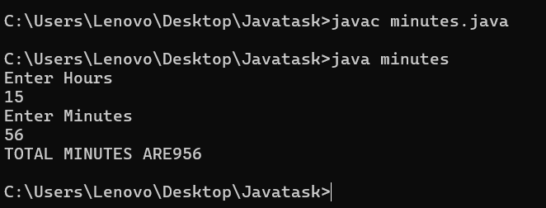

Q13. Write a java program to integral quotient and remainder of a division

Source Code

import java.util.Scanner;

class divi {

public static void main(String[] args) {

Scanner sc = new Scanner(System.in);

int A,B;

System.out.println("ENTER Numerator");

A=sc.nextInt();

System.out.println("Enter Denominator");

B=sc.nextInt();

int QUO = A/B;

int REM = A%B;

System.out.println("Quotient is : " + QUO);

System.out.println("Remainder is : " + REM);

}

}

**Output**

